**V1.0 FEATURES:**

* **Playable Character Controller**
* **Editable controller and 3rd person camera**
* **5 x Character colour variations**
* **Mecanim Ready**

This tool will allow you to get a heads start on your next character game.

Art assets are also supplied for you to use and try out. They can be used in your games (Environment model pieces, Particles, etc) including different colour material types and base animation which can be mixed as you like.

NOTE: No assets of this pack can be shared or resold.

What you need:

- A game idea. 😉

- Something to run around on.

What we supply:

Use the scriptableobject to tweak values on your character. Each variable has tooltips and the code is commented throughout. A new scriptableobject can be created by using the create menu.

The third person follow camera is automatically spawned in when assigned in the scriptableobject.

NOTE: there is a small issue with this when you have more than one character in your scene at the same time. You can remove the code in the OnValidate function from the RRCharacterController to drag a camera in yourself. Simply assign the follow Target and the character should find the correct camera itself.

**-> Script: RRThirdPersonFollowCamera: 3rd person Camera controller**

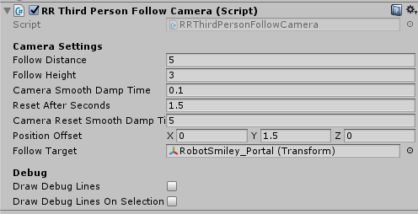

Drag this script to the camera node (Prefab supplied).

This is where you define the settings to place the camera relative to your character. The camera & script is a required for the character movement to function correctly. Not assigning the thirdpersonfollowcamera gives you different undesirable movement as the character depends on that object for its movement calculations

You can also tune your camera here (tooltips available)

Follow target: Choose your character root node.

**-->Script: RRCharacterControllerData – Movement controls**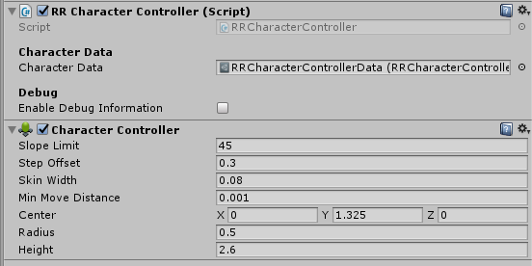

Add this script to the root character node.

Set limits and boundaries for the characters interactions within the game world here.

tooltips available

**->Script: RRCharacterAnimationData: Animation data & Movement Particles**

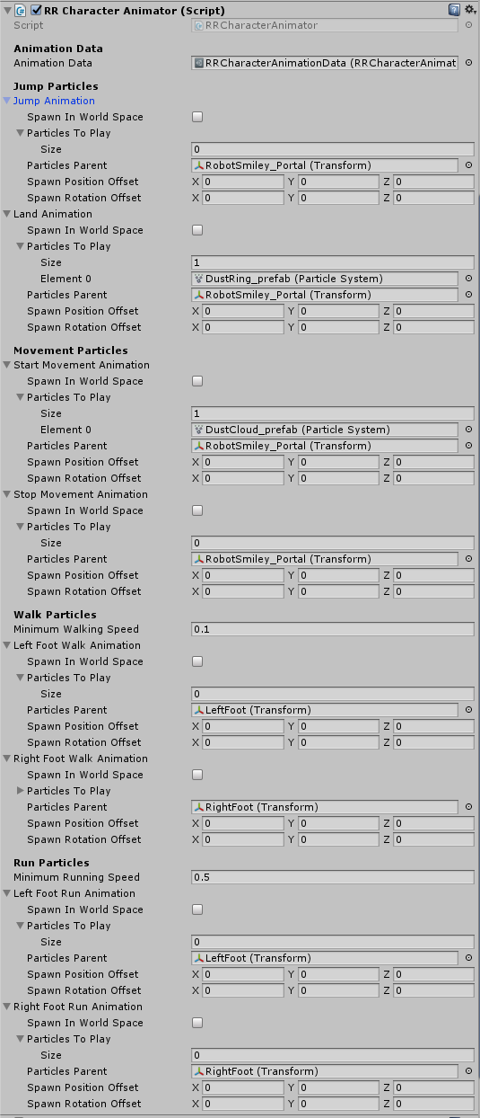

Optional particle placement for multiple situations. Jump/Land, Begin walk/Run, Left & Right foot, Stopping walk/run.

tooltips available

**->Scriptable object: RRCharacterAnimationData**



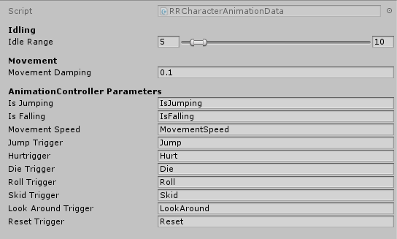

Idle range in seconds before playing the lookaround animation.

tooltips available

**->Scriptable object: RRCharacterControllerData**



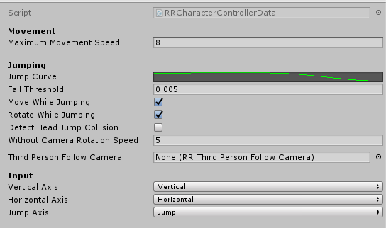

Global Movement and Jump settings

tooltips available

What can greatly help your experience?

1. Make sure all empty gameobjects you use are reset before you add elements to them.
2. Have a mesh to run around on.